**DATABASE SYSTEMS (5330 – 006)**

**PROJECT PHASE – III**

**TEAM MEMBERS**

1. SKANDAN SATHISH KUMAR (1002064126)
2. RAVI AILANI (1002026213)

**WEB INTERFACE**

**Dashboard of Arlington Sprouts Store**

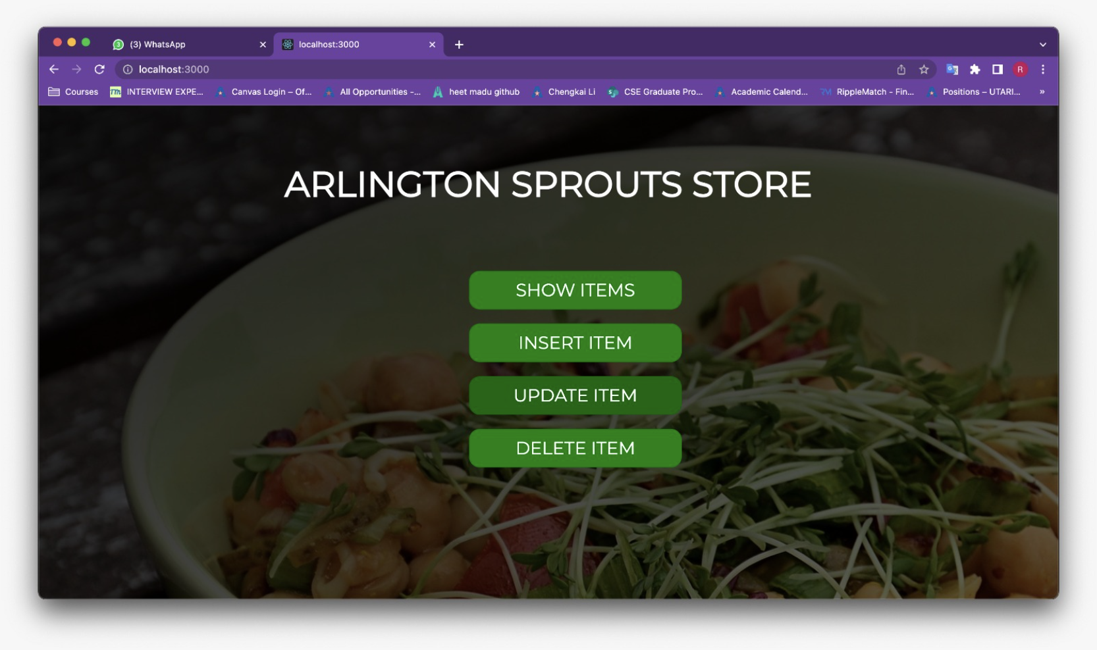

**Q1. Display the ITEM details based on any one of the following: item name or Item Id.**

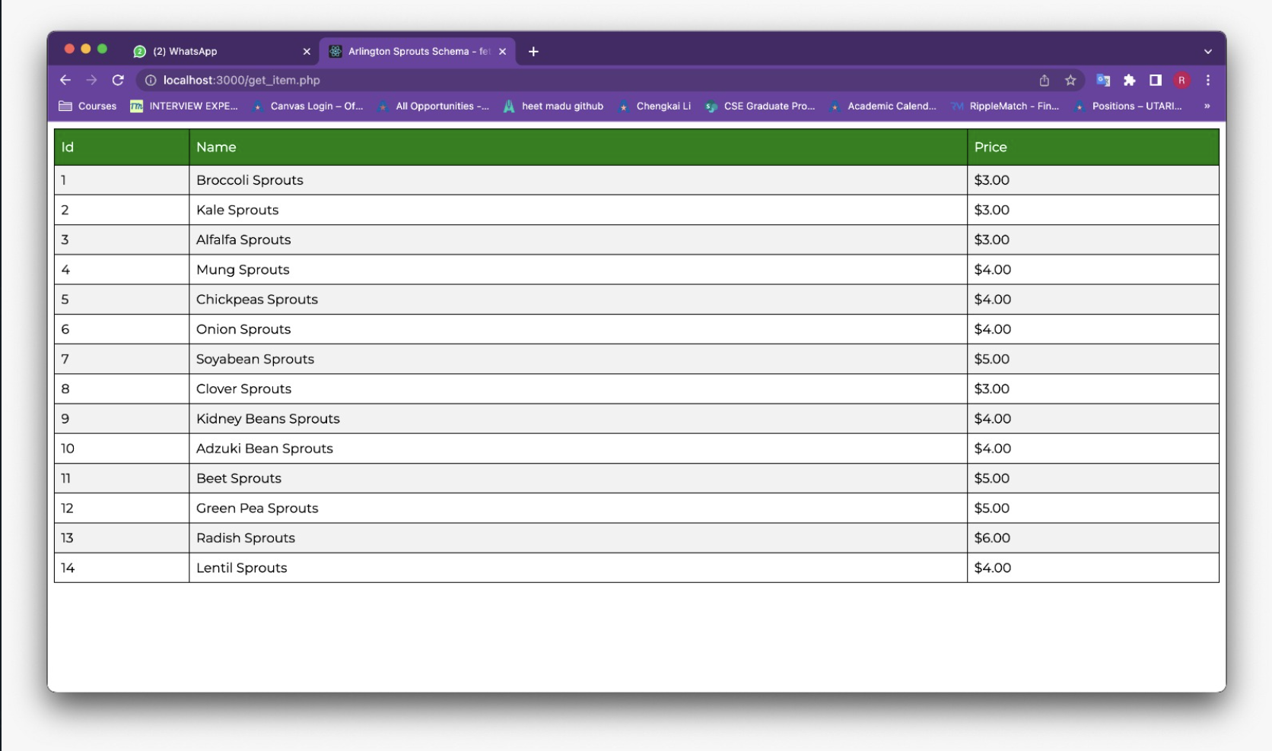

**Q2. Insert a new item “Carot Sprouts” in the Arlington Sprouts database using the web interface you created.**

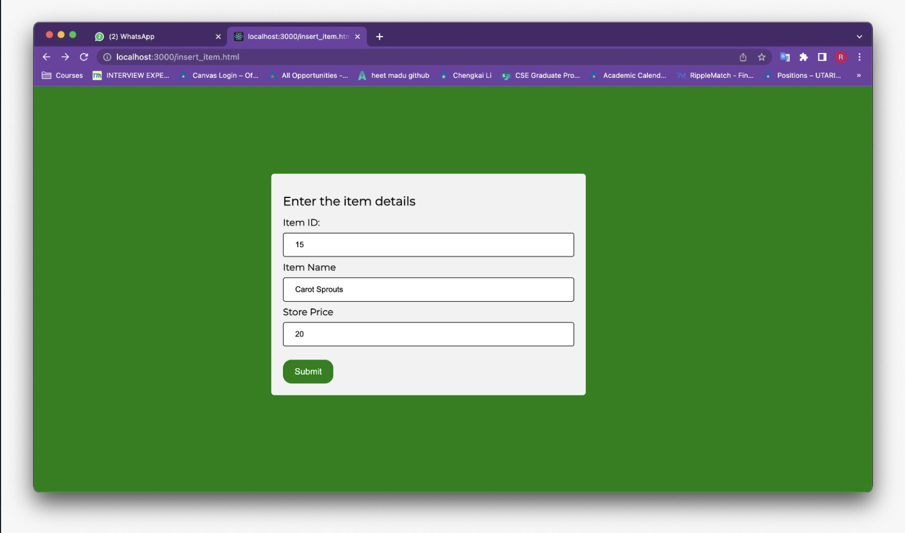

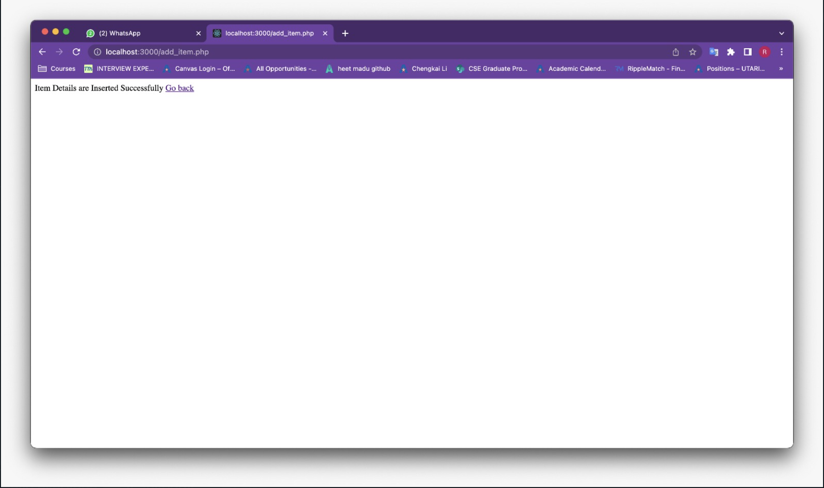

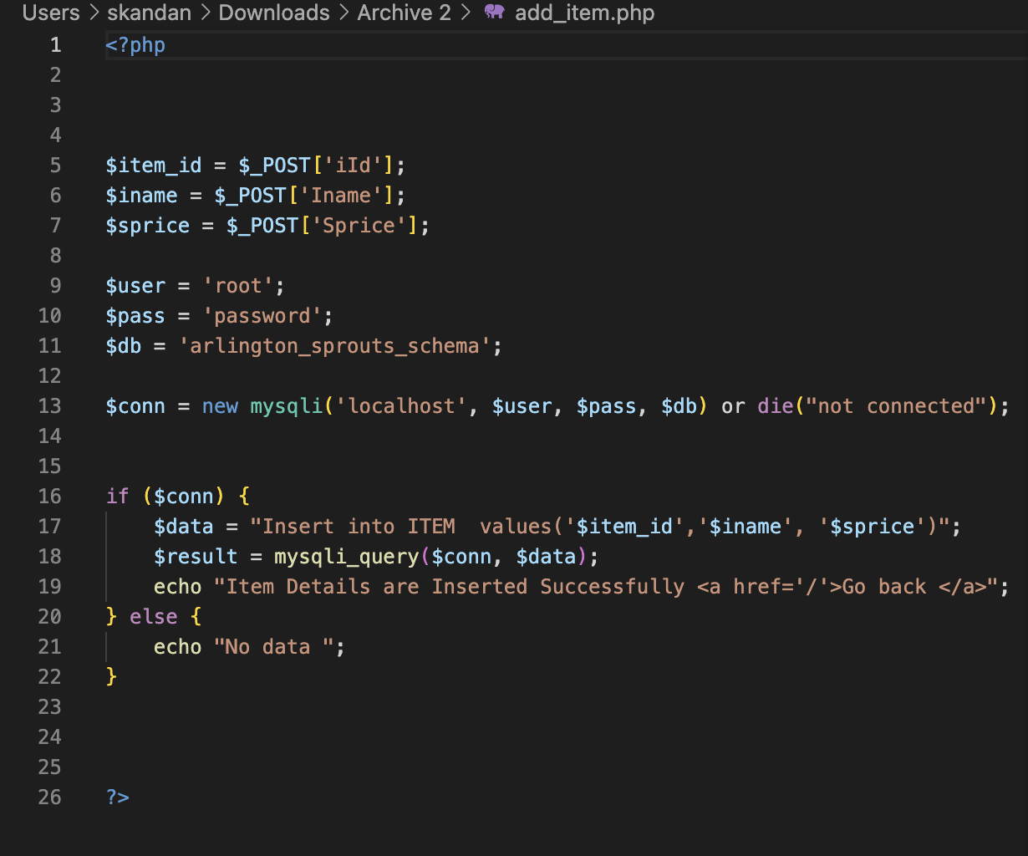

**Q3. Update the item record that you just added “Carot Sprouts” to “Carrot Sprouts” using the web interface you created.**

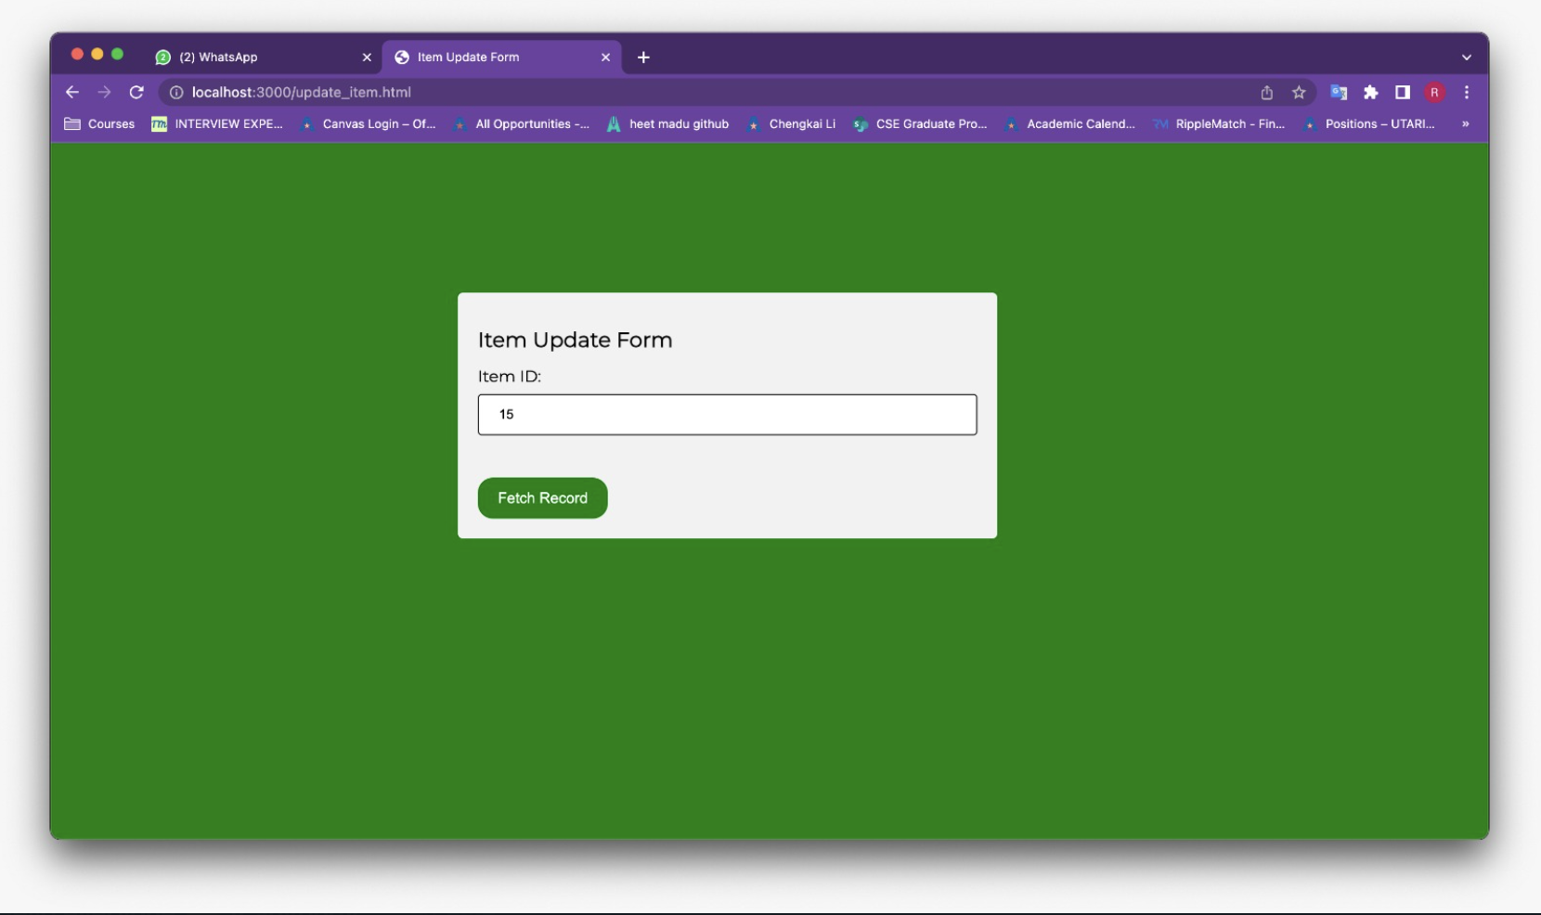

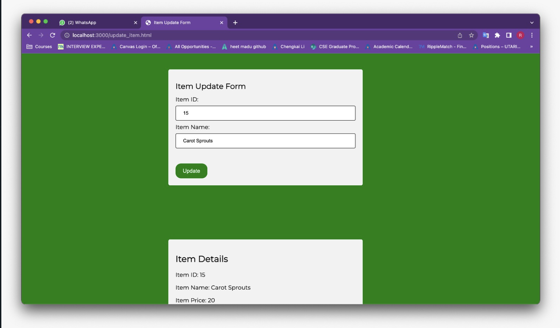

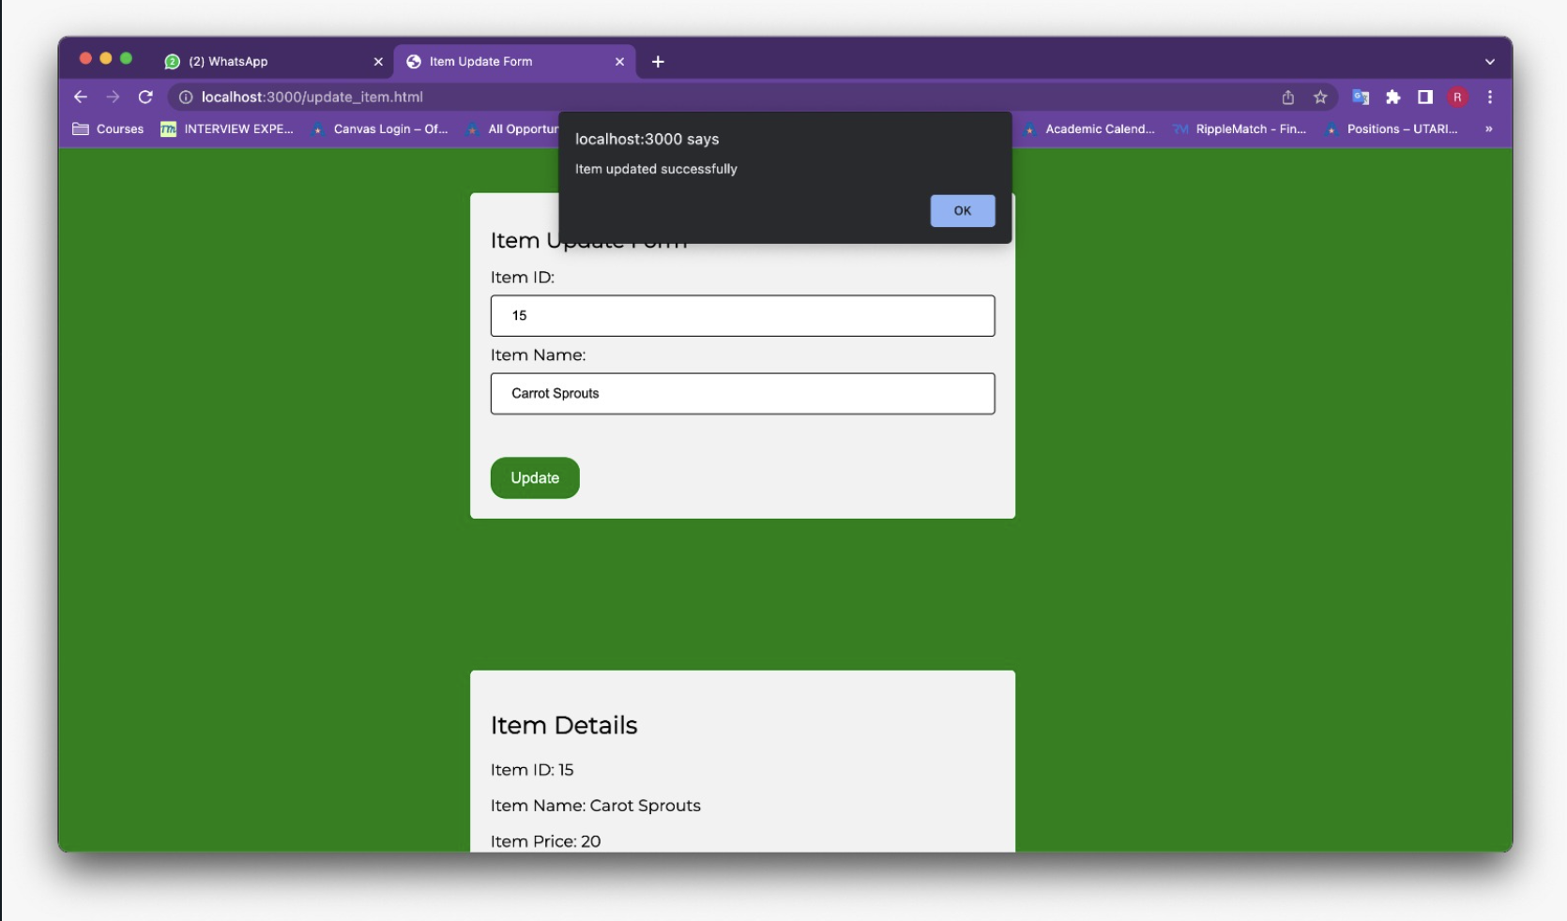

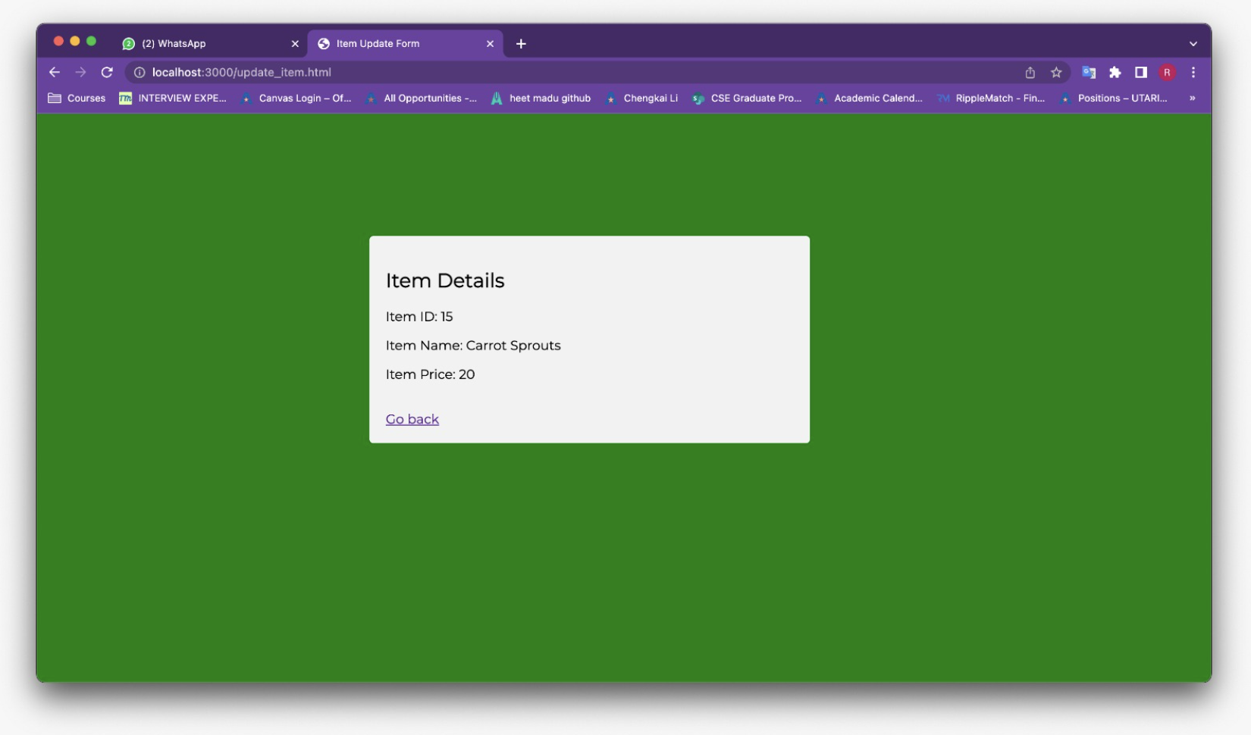

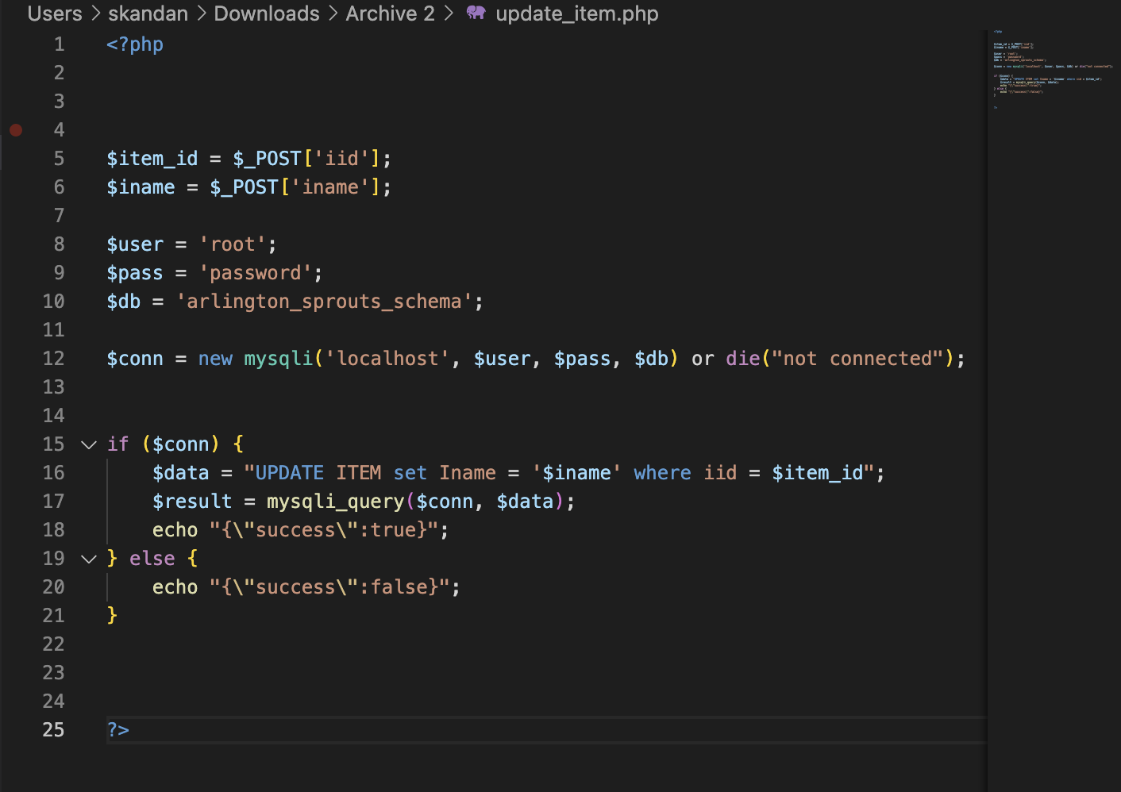

**Q4. Delete the item record “Carrot Sprouts” that you just added using the web interface you created.**

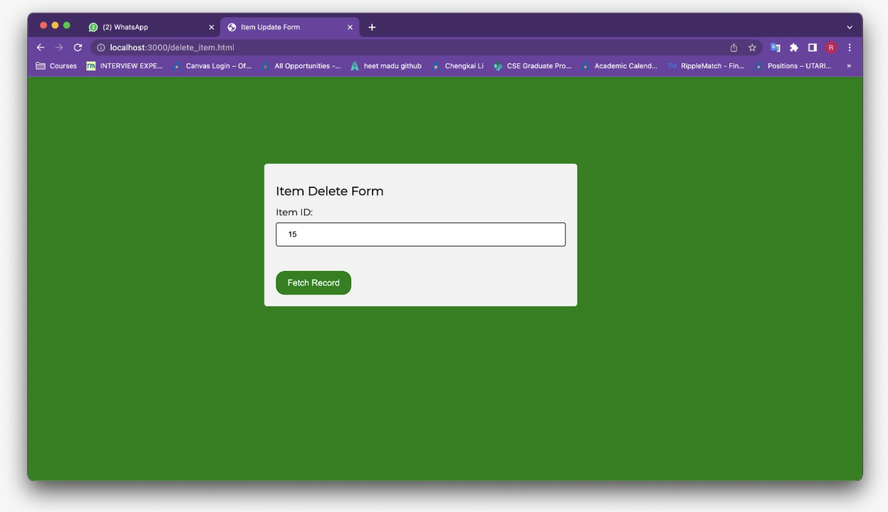

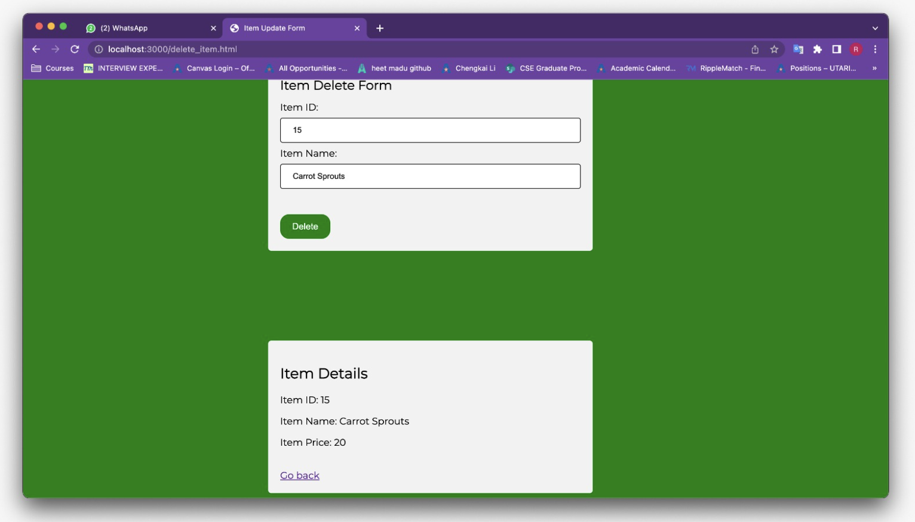

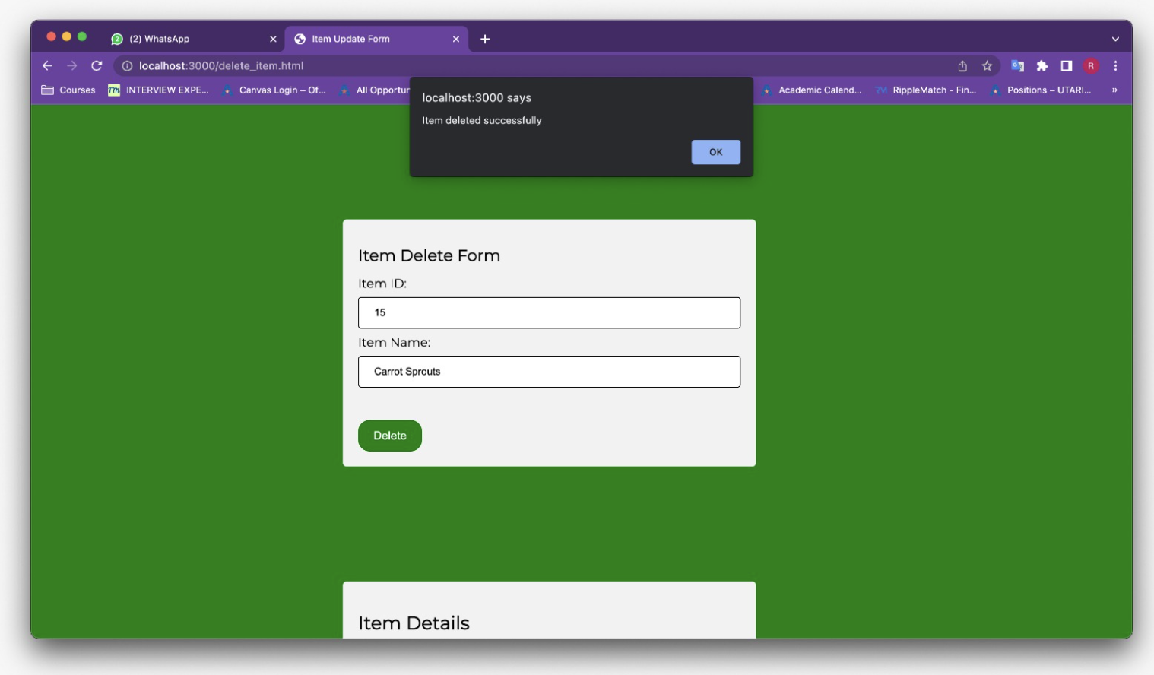

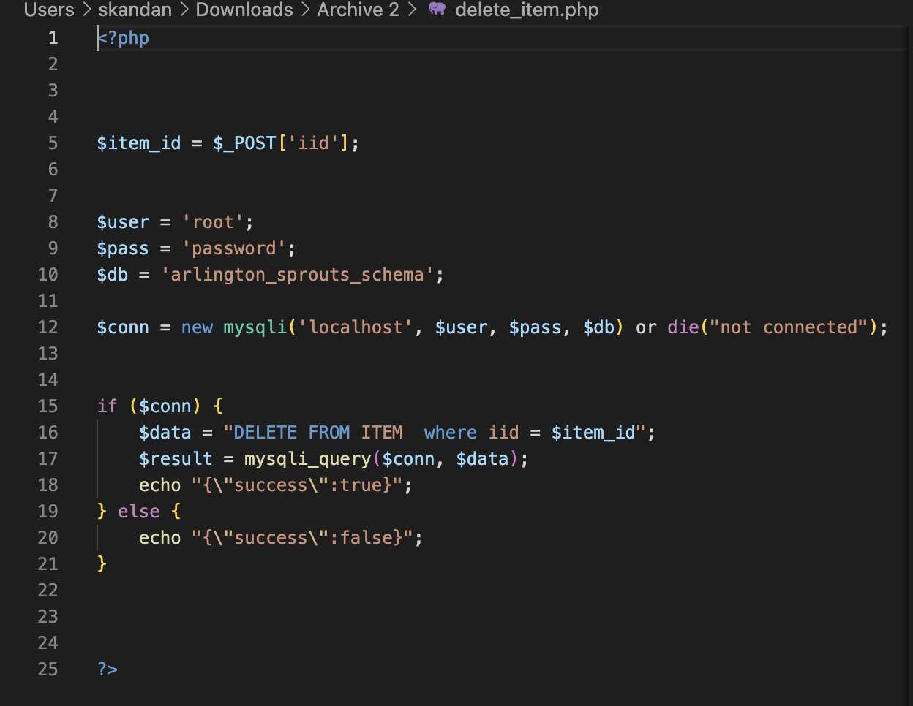

**VIEW BASED QUESTIONS**

**Create a view ItemView that displays a list of records where each record is comprised of the itemId as iId, item name as ItemName, the number of boxes of the item sold as NoOfBoxes, the item price as ItemPrice, the revenue generated by each item as ItemRevenue, and the number of customers as ItemCustomers who bought the item boxes at any of the Arlington Sprouts stores.**

**Write an SQL query to display the contents of the view ItemView.**

Create view ItemView as Select item.iId, item.Iname as ItemName,COALESCE(NoOfBoxes,0) as NoOfBoxes, item.sprice as ItemPrice, COALESCE(ItemRevenue,0) as ItemRevenue , COALESCE(ItemCustomers,0) as ItemCustomers From item left join (SELECT Order_item.iid as iId, SUM(icount) as NoOfBoxes, item.Iname as ItemName, COUNT(DISTINCT orders.cid) as ItemCustomers, SUM(COALESCE(oldprice.sprice, item.Sprice) * icount) AS ItemRevenue FROM orders INNER JOIN order_item ON orders.oid = order_item.oid INNER JOIN item ON item.iid = order_item.iid LEFT JOIN oldprice ON order_item.iid= oldprice.iid AND (orders.odate BETWEEN oldprice.sdate AND IFNULL(oldprice.edate, DATE('9999-12-31')) OR oldprice.sdate IS NULL) GROUP BY order_item.iid ) as a on item.iid = a.iId;

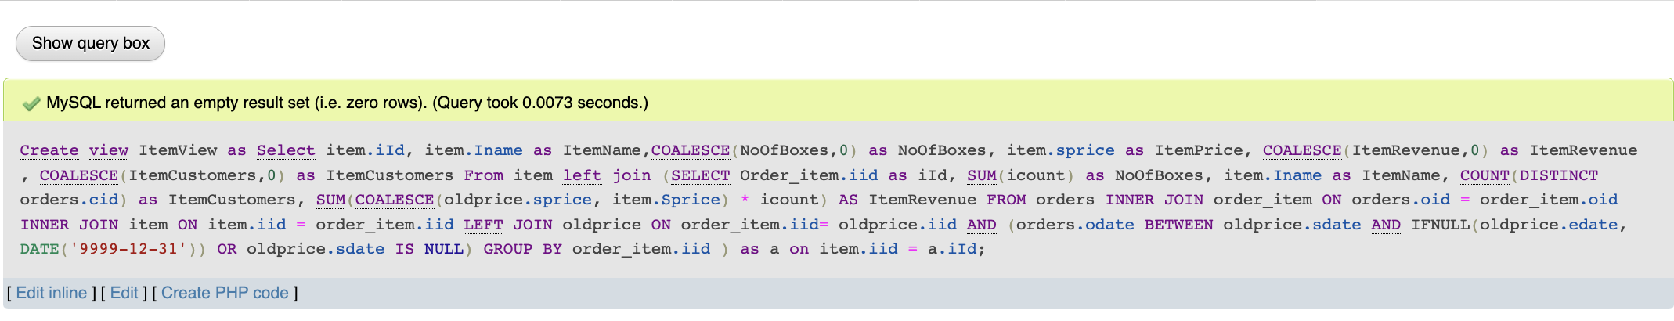

**QV1** Use the view ItemView to retrieve a list of records where each record is comprised of item Id, item name, the number of boxes of items sold, and the price of each box of the item for all items that cost more than $3.00 and that have been bought by customers.

SELECT iId, ItemName, NoOfBoxes, CONCAT('$', FORMAT(ItemPrice, 2)) as ItemPrice FROM ItemView WHERE ItemPrice > 3.00 AND ItemCustomers > 0;

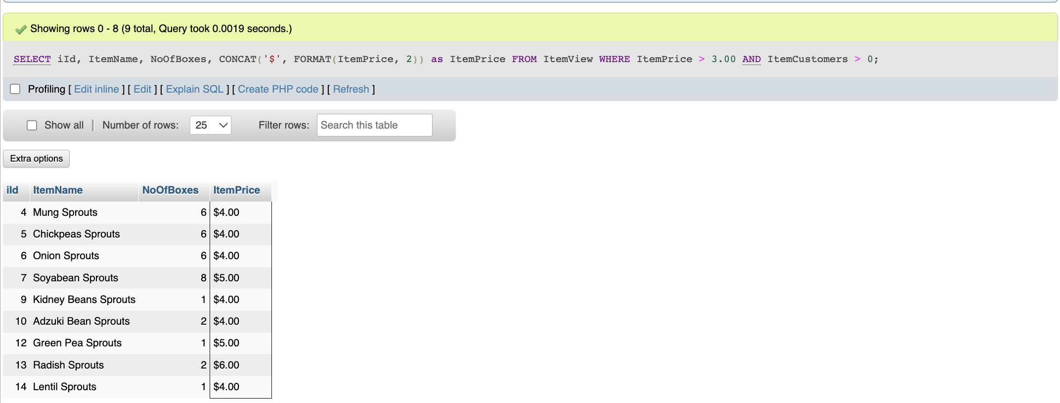

**QV2** Use the view ItemView to retrieve a list of records where each record is comprised of the item Name and the ItemRevenue for the item(s) that generated the minimum revenue in the database.

SELECT ItemName, CONCAT('$', FORMAT(ItemRevenue, 2)) as ItemRevenue FROM ItemView WHERE ItemRevenue = (SELECT MIN(ItemRevenue) FROM ItemView);

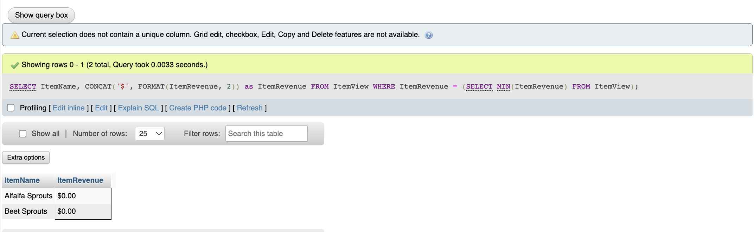

**QV3** Use the view ItemView to generate the min, max and average revenue generated by all the items in the ItemView.

SELECT CONCAT('$', FORMAT(MIN(ItemRevenue), 2)) AS MinItemRevenue, CONCAT('$',

FORMAT(MAX(ItemRevenue), 2)) AS MaxItemRevenue, CONCAT('$',

FORMAT(AVG(ItemRevenue), 2)) AS AvgItemRevenue FROM ItemView;

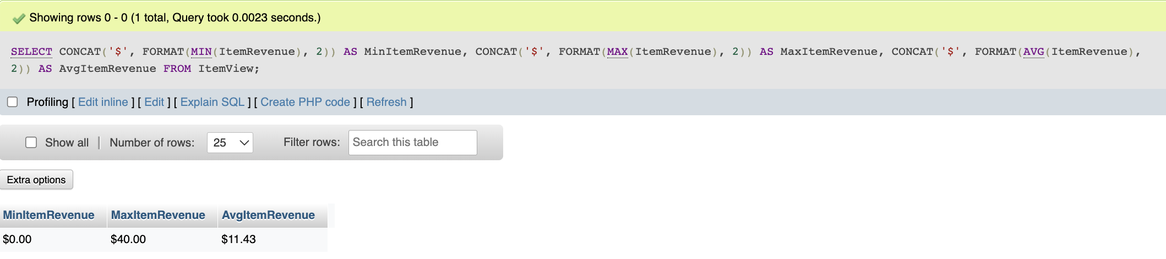

**QV4** Use the view ItemView to retrieve a list of records where each record is comprised of an item name along with the number of customers who bought it. Sort the list by the number of customers in descending order followed by item names in an ascending order.

SELECT ItemName, ItemCustomers FROM ItemView ORDER BY ItemCustomers DESC, ItemName ASC;

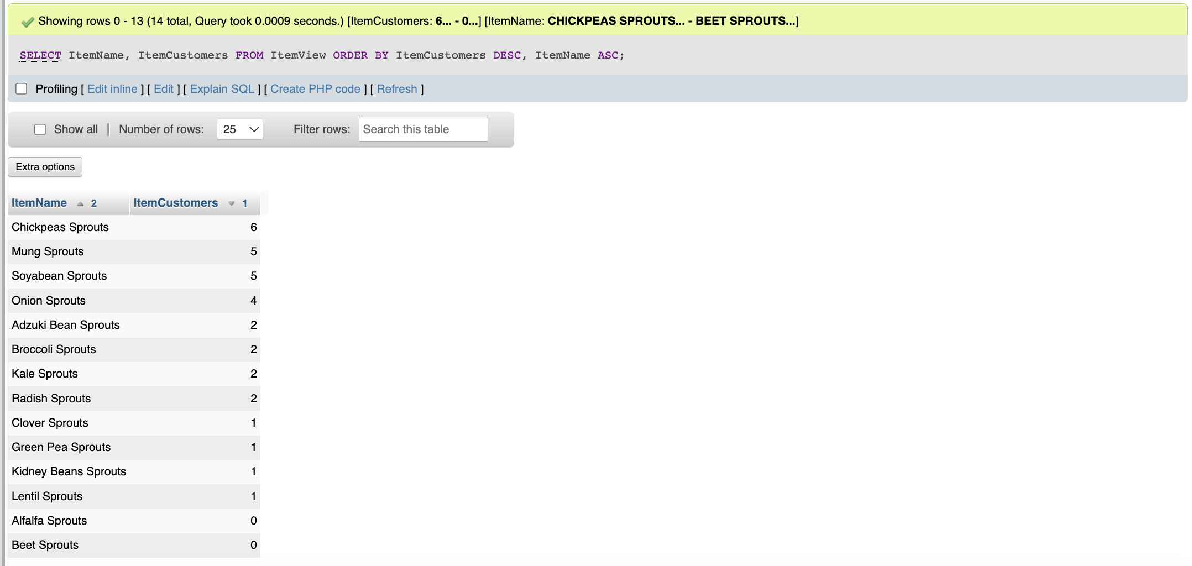

**QV5** Use the view ItemView to retrieve the total revenue earned, the total number of boxes sold and the average revenue per box sold by Arlington Sprouts as stored in the database.

SELECT CONCAT('$', FORMAT(SUM(ItemRevenue), 2)) AS TotalRevenue, SUM(NoOfBoxes) AS TotalBoxesSold, CONCAT('$', FORMAT(AVG (ItemRevenue/NoOfBoxes), 2)) AS “AvgRevenue/Box” FROM ItemView;

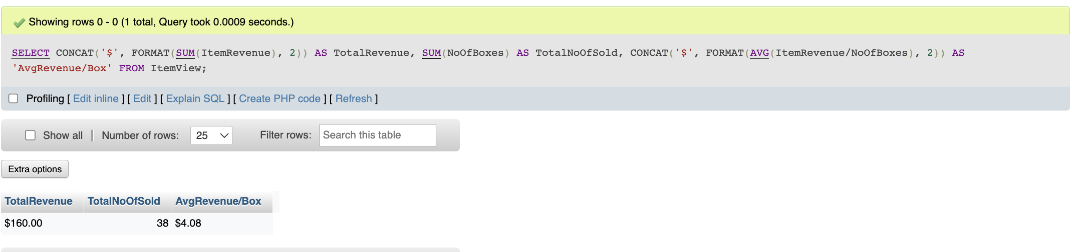

**HONOR CODE**

